**FRAUD DETECTION SYSTEM**

**IMPLEMENTATION REPORT**

**Recess Year 2**

**GROUP MEMBERS**

|  |  |
| --- | --- |
| **NAME** | **REGISTRATION NUMBER** |
| TUMUSIIME ARNOLD | 17/U/10549/EVE |
| TUSIIME ALLAN MUHANGUZI | 17/U/10630/EVE |
| MUYANJA RODNEY | 17/U/6819/EVE |
| SHAKA STEPHEN | 16/U/20180/EVE |

The fraude_detection data analysis is intended to give stakeholders insights on the various accounts so as to avoid fraud in the companies, we also give our stakeholders various behaviors of the kinds of accounts they should watch out for and control.

Below we take a look at the “bad accounts “and the “good accounts” comparing their numbers,

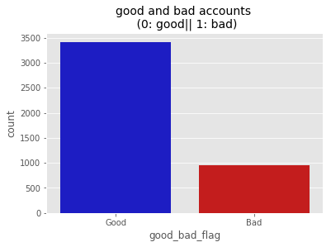

The graph shows that the good accounts are more than the bad accounts, although there’s a considerable number of bad amounts and our goal is detect them.

So, to do this we look at ways in which they arise in the company.

Below we take a look at common loans applied for and given out,

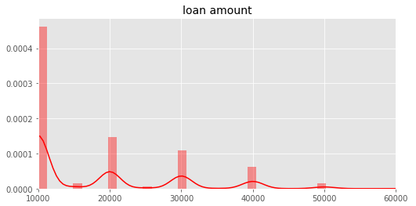

The graph shows that most loans are given out are of the least amount possible that is 10000, and the least loans are availed to the those borrowing high amounts of money, this is also to either avoid fraud or stakeholders’ policies on the loans to be given out.

Below we took a look at the amount of debts depending on the loans given and the interests on such loans,

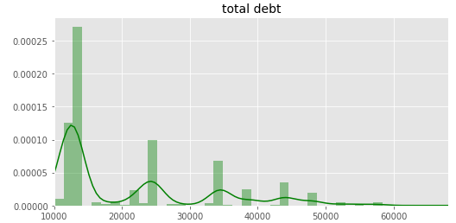

The interest rates range from 10% to more than 50% of the original loan regardless of the term days allotted. The above graph of total debt corresponds the debts due and the kind of loans given out as shown in the graph before loan amount depending on the above percentages.

Next, we take a look at loan amounts against term days, here we notice a pattern in the term days given depending on the amount of the loan,

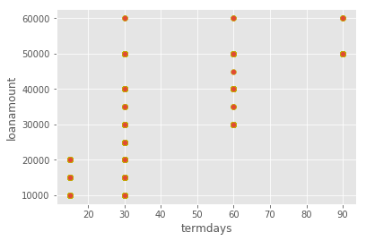

Loans of the least amount availed are mostly given less termdays with in which to pay back, and as the loan amount increases, the termdays allotted also increase. Termdays range from 15 days to 90days (which are the least).

Finally, we take a look at the most commonly frauded accounts as shown below,

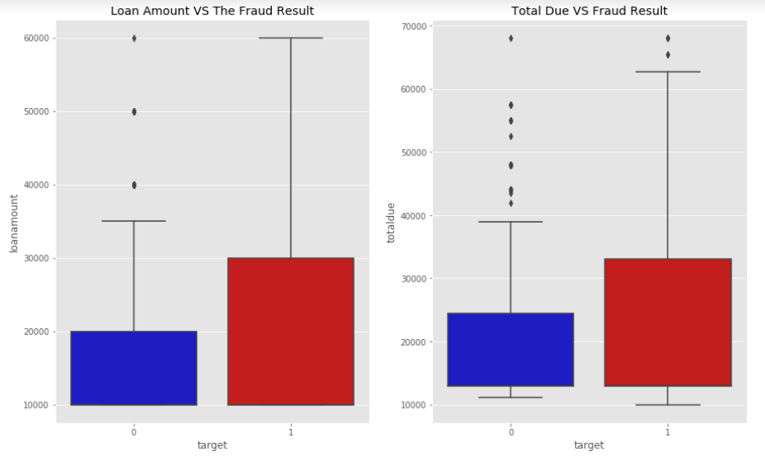

Depending on the data analyzed in the box plot above, **Good Accounts: 1 and Bad accounts: 0**. We can see that there are many outliers in the Bad Accounts above the amount of 40,000. This is either due to human error in entering the records, or these are actual losses.

In the finance sector, we take every possible error as a very big set-back. The company has take this serious and act quickly.

**Recommendations to our stakeholders.**

Our strong advice to our stakeholders is:

1. To increase on the security layers like providing assets that are worth the asked loan, among others that their clients have to go through to acquire loans that are 40,000 and above.
2. To offer loans above 40,000 to account holders that are trusted based on their previous loan repayment plans